Installing Docker

**dnf config-manager --add-repo=https://download.docker.com/linux/centos/docker-ce.repo**

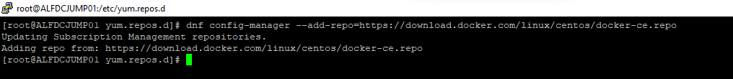

**dnf list docker-ce --showduplicates | sort –r**

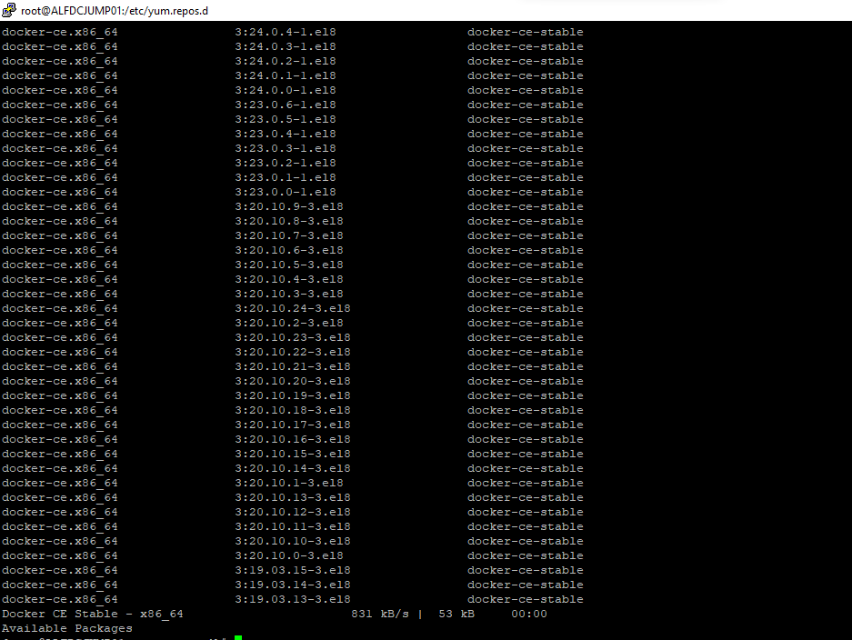

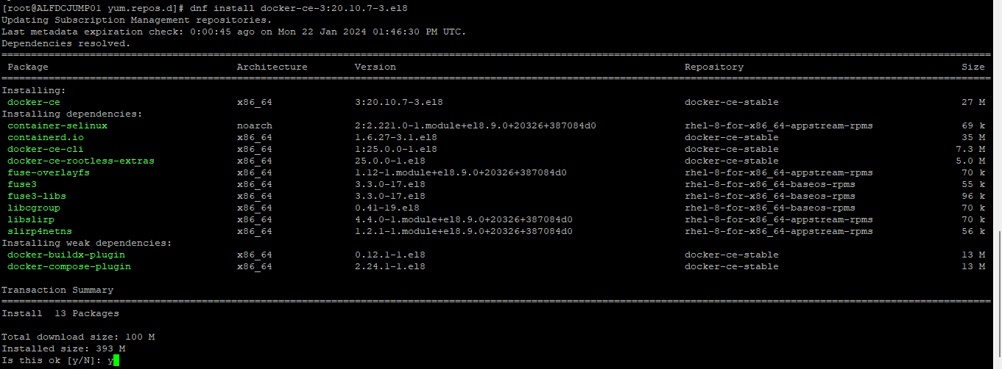

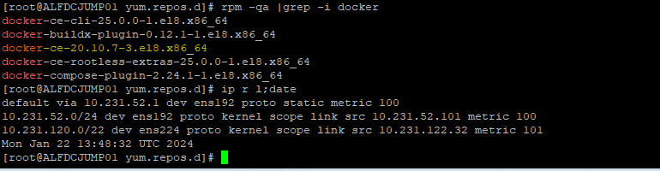

Installing Red Hat Open JDK 11.0.21.0.9-1 and Red Hat Open JRE 11.0.21.0.9-1

yum install java-11

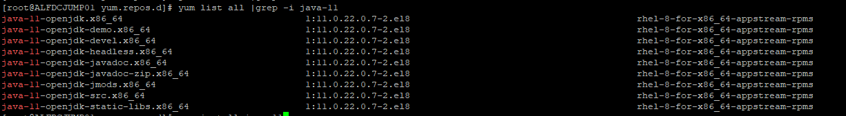

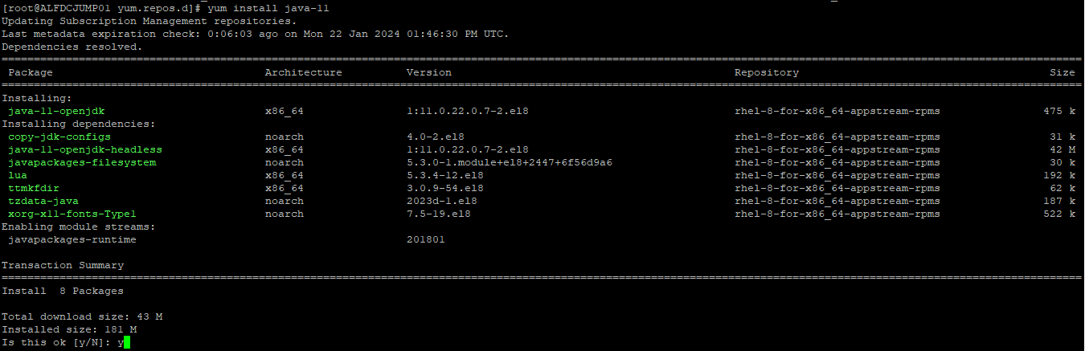

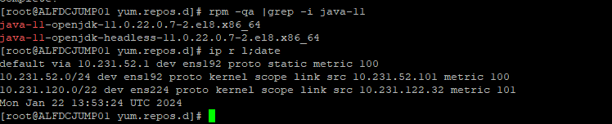

Installing Python 3.10.0

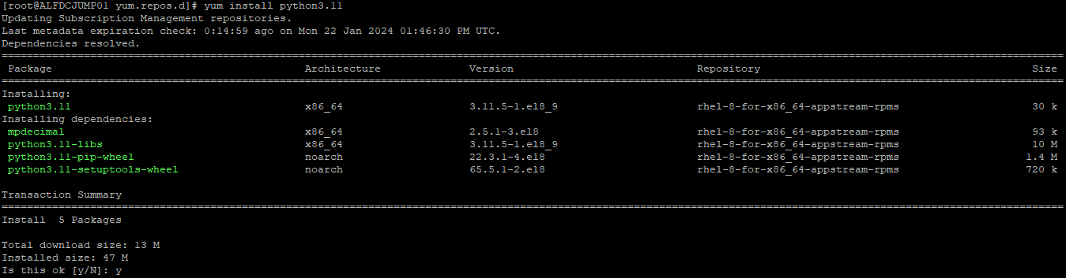

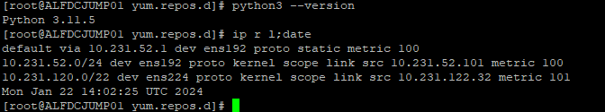

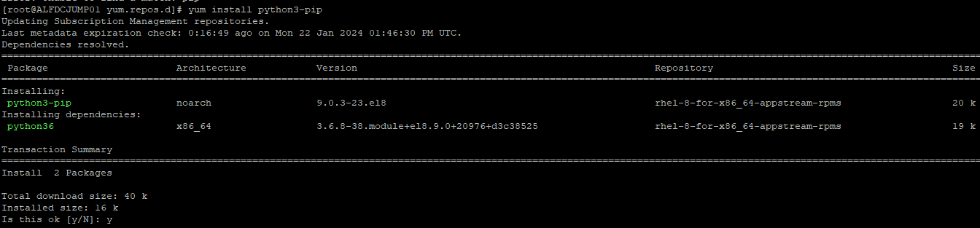

Installing Ansible 5.7.0

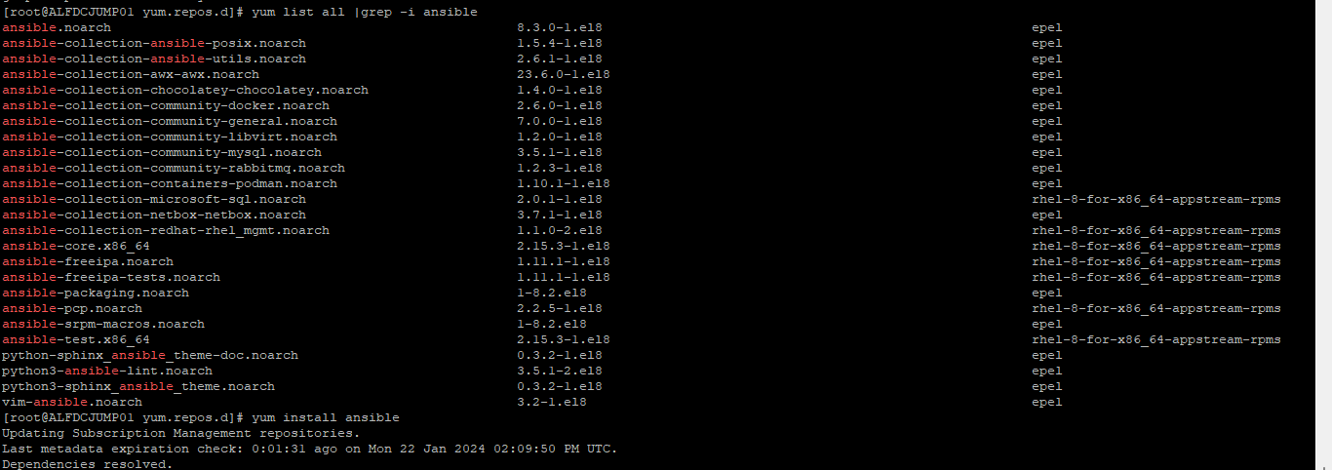

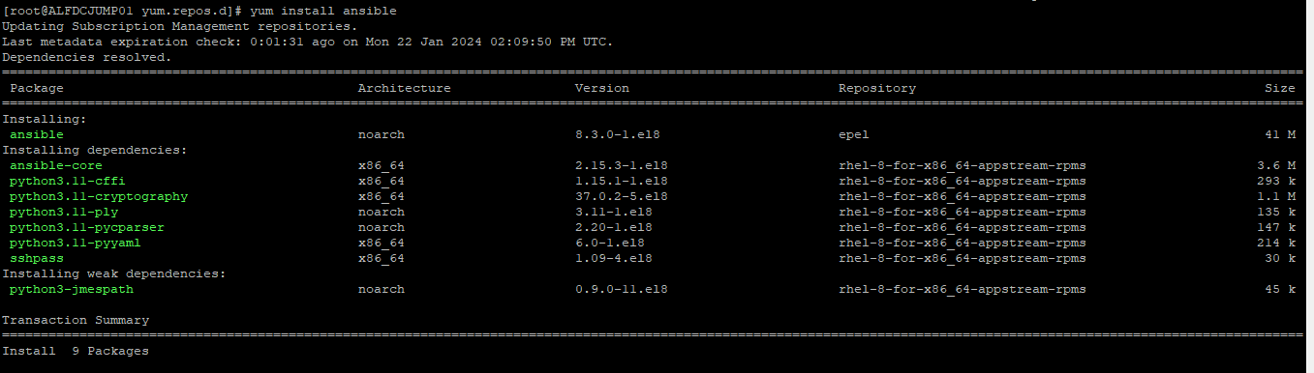

Installing Python Module (OpenShift) 0.13.1 and Python Module (jmespath) 1.0.0

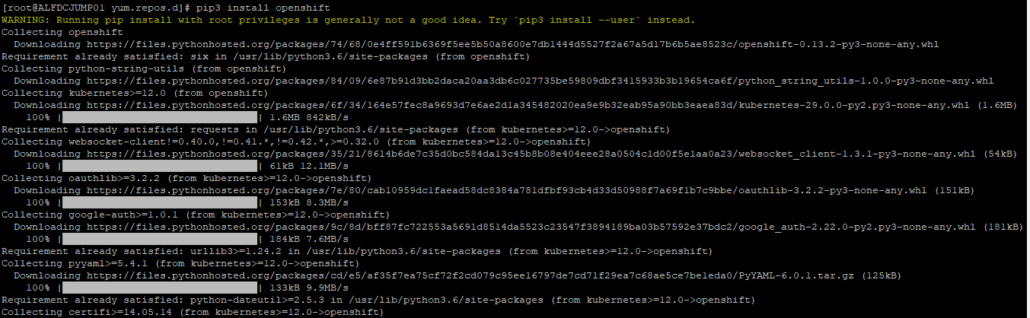

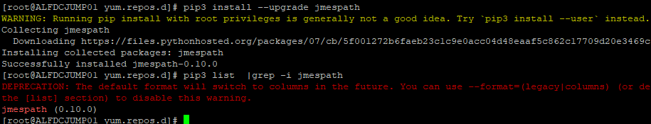

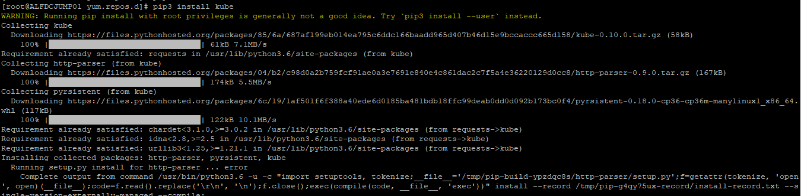

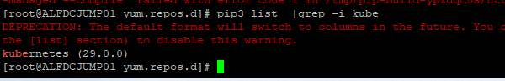

Install nodejs

curl -sL https://rpm.nodesource.com/setup_16.x | sudo -E bash –

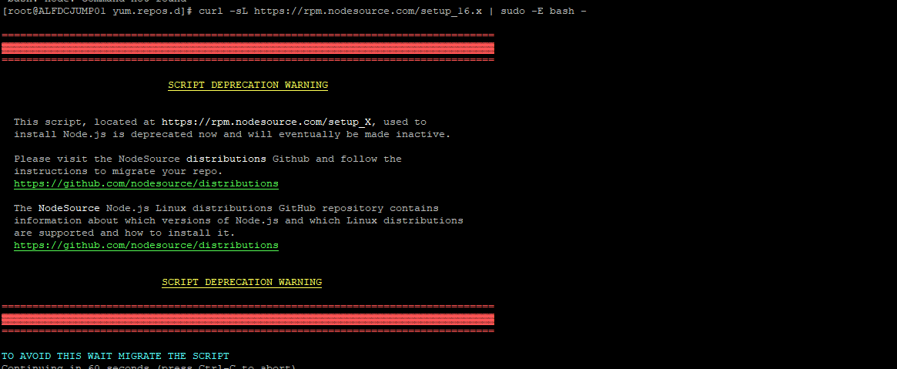

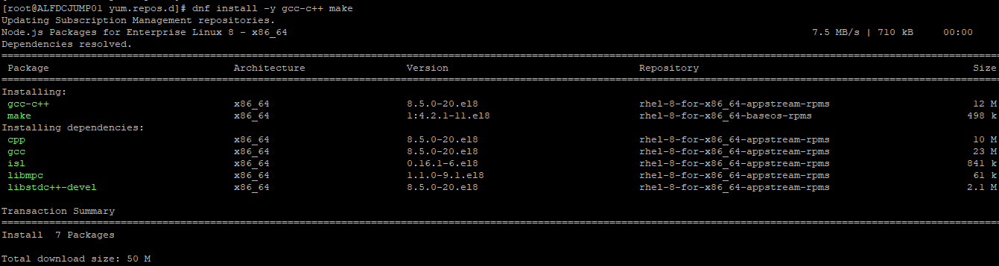

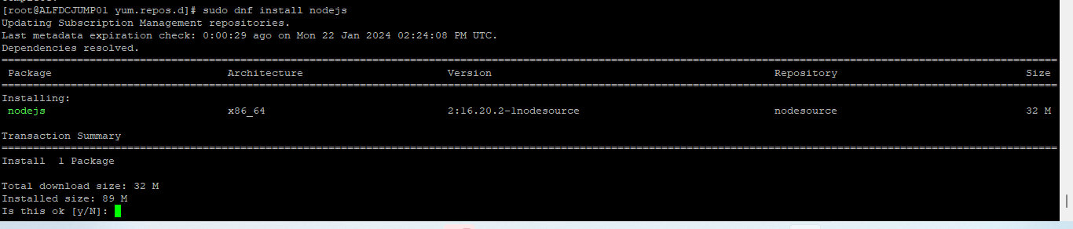

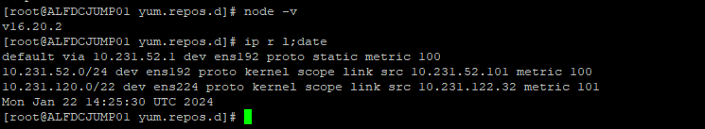

**Install PostgreSQL and pgAdmin**

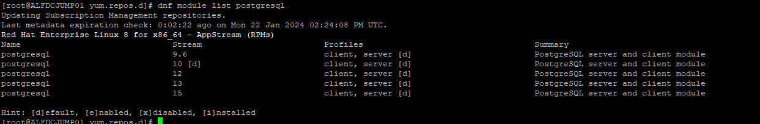

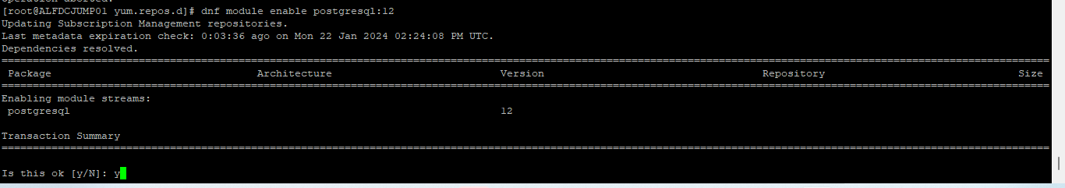

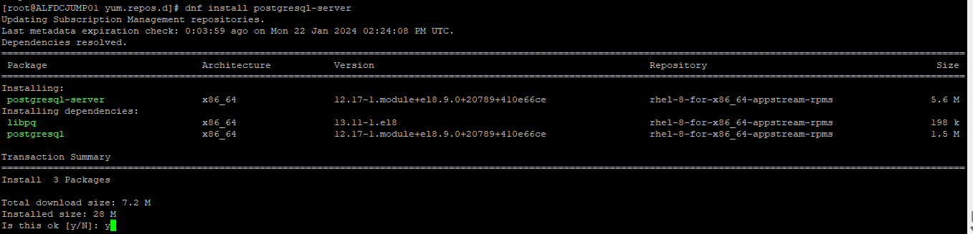

**Installing GITLAB**

**curl -s https://packages.gitlab.com/install/repositories/gitlab/gitlab-ce/script.rpm.sh | sudo bash**

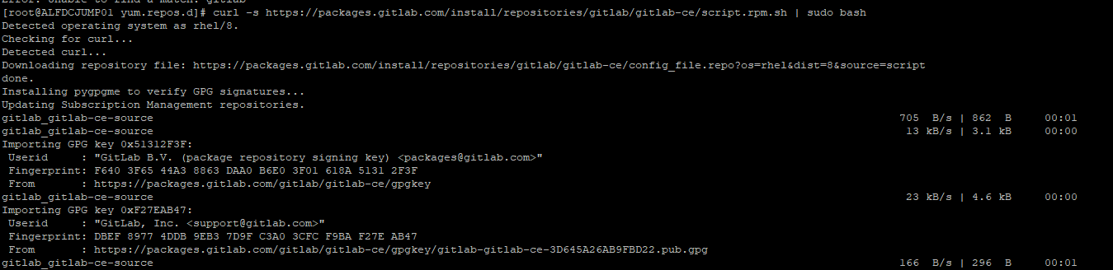

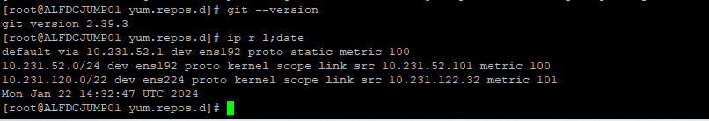

**Installing postman**

dnf -q install <https://dl.fedoraproject.org/pub/epel/epel-release-latest-8.noarch.rpm>



